PROJECT REPORT
ON
FACE RECOGNITION ATTENDANCE SYSTEM
BY
JAI NANDAN
UNIVERSITY ROLL NUMBER: 23303131
GAGANDEEP
UNIVERSITY ROLL NUMBER: 23303096
GAGANDEEP SINGH
UNIVERSITY ROLL NUMBER: 23303097



DEPARTMENT OF COMPUTER SCIENCE AND ENGINEERING
SARDAR BEANT SINGH STATE UNIVERSITY, GURDASPU

Acknowledgement
I would like to express my sincere gratitude to my project guide(DEEPANSI NANDA MAM), faculty members, and all those who supported the preparation of this project report. Their guidance helped in understanding the practical aspects of software design, project documentation, user interface planning, and the disciplined presentation of a complete academic project.
I am also thankful to my institution for providing the environment in which this project could be studied and documented. The availability of laboratory resources, programming tools, and practical learning opportunities made it possible to observe how a real attendance automation system is organized from a source-level perspective.
Special appreciation goes to the developers of Python, Tkinter, OpenCV, Pillow, and MySQL connectivity tools, because these technologies allow simple code to be transformed into a useful desktop application. The project would not have been possible without the robustness of these libraries and the openness of the surrounding developer community.
Finally, I thank my friends and classmates for their suggestions, encouragement, and practical discussions. Their feedback helped improve the clarity of the report and encouraged a more detailed explanation of the project structure, modules, and expected workflow.

Abstract

The Face Recognition Based Attendance Management System is a desktop application developed to automate attendance marking using face recognition technology. Traditional attendance methods are time-consuming and prone to errors and proxy entries. This system overcomes these limitations by integrating a graphical user interface with real-time face detection and recognition using OpenCV.

The application follows a modular structure, including separate components for login management, student data handling, attendance tracking, model training, and face recognition. Facial images are collected, processed, and used to train the system for accurate identification. Once a face is recognized, attendance is automatically recorded and stored in a structured format such as CSV or database.

The system improves efficiency, accuracy, and security in attendance management while reducing manual effort. This project demonstrates the practical application of computer vision and Python programming in solving real-world problems and can be further enhanced with advanced AI techniques and cloud integration.

Table of Contents
1. Introduction------------------------------------------------------------------------------------------6-8
2. Problem Statement and Need for the System---------------------------------------------------9-10
3. Objectives and Scope------------------------------------------------------------------------------11-12
4. Existing System and Limitations-----------------------------------------------------------------13-14
5. Proposed System Overview-----------------------------------------------------------------------15-16
6. Technology Stack and Development Environment--------------------------------------------17-19
7. Project Structure and File Organization---------------------------------------------------------20-21
8. Module Wise Description-------------------------------------------------------------------------22-29
9. System Design and Architecture-----------------------------------------------------------------30-31
10. Database Design and Data Flow----------------------------------------------------------------32-33
11. Algorithms and Working Principles------------------------------------------------------------34-35
12. Testing, Validation, and Output Analysis-----------------------------------------------------36-37
13. Advantages, Limitations, and Future Scope--------------------------------------------------38-39
14. Installation and User Guide---------------------------------------------------------------------40-41
15. Conclusion and References---------------------------------------------------------------------42

List of Tables and Figures
Table 1: Project Identification Details
Table 2: Technology Stack Used in the Project
Table 3: Major Files and Their Roles
Table 4: Hardware and Software Requirements
Table 5: Suggested Database Tables
Table 6: Test Case Summary
Figure 1: High-Level Architecture of the Attendance System
Figure 2: Module Interaction Flow
Figure3:FaceRecognitionAttendanceWorkflow
Figure 4: Project Folder Structure Screenshot

Chapter 1: Introduction
Attendance is one of the most important administrative activities in schools, colleges, coaching centers, and training institutions. Although it appears simple, attendance collection affects discipline, academic planning, performance assessment, and institutional reporting. When attendance is recorded manually, a large amount of class time is spent on roll calls, signature sheets, or verbal confirmation. In crowded classrooms, those methods are slow and often produce inaccurate records. The need for a more reliable and automated solution has therefore become increasingly important in modern educational environments.
The growth of digital learning and the availability of inexpensive computer vision tools have made attendance automation practical even for student-level projects. A face recognition based attendance system uses the identity of a person’s face as the basis for recording presence. Instead of asking each student to sign a paper register, the camera observes the classroom, recognizes the student from stored facial features, and marks attendance in a database. This reduces manual intervention and also reduces the chance of proxy attendance because the system expects a live facial match before logging the record.
The project reflected in the folder structure is built using Python and a set of supporting libraries such as Tkinter, OpenCV, Pillow, and MySQL connectivity tools. These libraries are well suited for desktop applications because they allow the developer to design windows, manage images, interact with a database, and process camera frames in real time. The structure of the files suggests a modular organization in which each major task is isolated into a separate script. Such an arrangement is valuable because it makes the code easier to understand, test, and improve later.
A project report should not only describe what the software does, but also explain why the chosen solution is useful and how the different components cooperate. This report therefore treats the source folder as a case study in practical software engineering. The following chapters describe the problem addressed by the system, the functional goals, the technology stack, the roles of the visible source files, the expected architecture, and the workflow followed during face recognition and attendance marking.

1.1 Background of the Problem
Educational institutions have always required attendance records for academic and administrative reasons. Attendance data is used to measure class participation, detect absenteeism, enforce institutional policies, and sometimes support eligibility for examinations or internal assessments. In many institutes, however, the attendance process still depends on manual methods. A teacher may call names one by one or ask students to sign a register. These methods are familiar, but they introduce delay, recording mistakes, and opportunities for manipulation.
Automation has become a natural response to these limitations. Barcode cards, RFID badges, fingerprint readers, and facial recognition are all technologies that can speed up attendance collection. Among them, face recognition is especially attractive because it does not require students to carry an additional card or remember to scan a device. A face is always present, and when supported by proper privacy and access controls, it can become a convenient identity token. This project explores that idea in a simple desktop implementation.
The current project is also valuable as a learning exercise. It exposes the learner to the full cycle of software development: interface creation, data handling, image processing, database connectivity, model training, system testing, and documentation. Because the folder shows distinct modules such as login, student management, training, recognition, attendance, and support pages, the project is a good example of how a small application can be organized like a real-world software product.

1.2 Significance of the Project
The significance of this project lies in its practical utility. A working attendance automation system can save time every day, especially in classes with large student strength. Even a few minutes saved at the start of each lecture accumulate into a substantial amount of productive time across an academic term. The project also supports better record keeping because attendance entries are stored electronically and can be queried later for reports.
Another important aspect is reliability. Manual registers can be misplaced, damaged, or filled with inconsistent handwriting. Spreadsheet-based methods can suffer from accidental editing or incomplete entries. A database-backed face recognition system reduces these issues by keeping structured attendance records and by linking each presence mark to a recognized identity. In addition, it produces a traceable event log that is easier to audit than paper-based systems.
The project is significant from the perspective of future learning too. Face recognition combines concepts from programming, mathematics, image analysis, and system design. Even when a student-level project uses a simplified implementation, the overall architecture introduces important engineering ideas such as separation of concerns, reusability, and modularity. These ideas are transferable to many other software projects beyond attendance management.

1.3 Structure of the Report
The report is arranged in a sequence that moves from general discussion to specific implementation details. The first chapters explain the motivation for the system, the challenges of the existing approach, and the objectives of the project. The middle chapters focus on technologies, file structure, module behavior, architecture, database design, and algorithmic workflow. The later chapters discuss testing, limitations, installation, and future improvements.
This structure is intentional. A project report becomes easier to read when the reader is first given the background and then gradually introduced to the details. In this way, the report is not just a collection of technical notes. It becomes a coherent document that can be used by teachers, evaluators, project guides, and students who want to understand the application thoroughly.
Project Information | Details
Project Title | Face Recognition Based Attendance Management System
Domain | Educational administration and computer vision
Primary Language | Python
UI Framework | Tkinter
Database | MySQL (through mysql.connector)
Image Processing | OpenCV and Haar cascade detection
Purpose | Automated attendance recording using face recognition

Chapter 2: Problem Statement and Need for the System
Manual attendance methods create several practical problems. First, they consume classroom time every day. A teacher must announce names, wait for responses, and correct missed entries, which interrupts the flow of the session. Second, manual records are prone to mistakes. A student may be marked present by mistake, absent despite being in class, or counted twice if the record is not managed carefully. Third, the process is difficult to audit when it depends on paper documents or loosely maintained spreadsheets.
Proxy attendance is another major issue. When a student asks a friend to answer on his or her behalf, the institution receives a false picture of presence. Such behavior affects discipline and weakens the credibility of attendance records. In the long term, poor record quality can influence academic decisions, attendance-based eligibility, and communication with guardians. An automated biometric approach helps address this issue because it checks identity through facial features rather than through verbal confirmation alone.
Institutions also need attendance records that can be searched quickly. For example, a teacher may need the attendance percentage of a particular student, a summary for a week, or a report for a semester. In manual systems, such queries require extra effort. In a software system, the same information can be retrieved from a database within seconds. The proposed project therefore improves both operational speed and record accessibility.
The need for this system is not limited to large organizations. Even small educational centers benefit from automation because they often operate with limited administrative staff. A desktop-based attendance application can function in a computer laboratory or office environment without requiring expensive cloud infrastructure. This makes the project a practical solution for institutions seeking a balance between functionality, affordability, and ease of deployment.

2.1 Problem Statement
Design and implement a desktop-based attendance management system that can detect a student’s face, recognize the person against stored training data, and automatically record attendance in a database with minimal manual intervention.

2.2 Key Challenges
- The system must handle differences in lighting, face angle, and temporary changes in appearance.
- The application must provide a user-friendly interface so that non-technical staff can operate it easily.
- The database must store records in a structured way and avoid duplicate or inconsistent entries.
- The recognition process must be fast enough to support practical classroom use.
- The project must be modular so that training, recognition, and reporting can be maintained separately.

2.3 Motivation Behind Automation
Automation is attractive because it can convert a routine repetitive task into an almost invisible background process. In a classroom, attendance should not dominate the beginning of the lecture. Instead, it should happen in a few seconds while the teacher focuses on the session. A face recognition system reduces the manual burden and improves the overall classroom rhythm.
The project is also motivated by the modern availability of open-source libraries. Python makes it possible to combine database operations, graphical interfaces, and computer vision within one application. OpenCV supplies image capture and face detection support, while Tkinter provides accessible desktop windows. These tools lower the barrier to entry for students and developers who want to build practical AI-assisted software.

Chapter 3: Objectives and Scope
The primary objective of the project is to develop a reliable attendance recording system that identifies students by face and stores attendance digitally. The system must reduce the need for manual entry and should support quick operation from a simple graphical interface. Because it is designed as a desktop application, the software should remain approachable for users who are familiar with standard Windows-style applications.
A second objective is modularity. The visible project files indicate that each major activity has its own script. This structure is important because attendance systems normally evolve over time. Student data fields may change, new reports may be requested, and the recognition workflow may be improved later. Modular design helps isolate these changes and reduces the risk of introducing errors into unrelated parts of the application.
A third objective is educational. The project is meant to demonstrate the practical application of multiple software tools in a single solution. Students often study Python, image processing, databases, and user interfaces as separate topics. This project unifies them into one meaningful system, showing how theory becomes a usable product when the parts are integrated correctly.
A fourth objective is record integrity. The application should save attendance in a format that can be verified and reused for reporting. This implies the use of database tables, structured input forms, and clear links between student identity and attendance timestamps. By storing data properly, the system becomes more useful than a temporary on-screen display.

3.1 General Objectives
- To allow registration of students with basic demographic and academic information.
- To train the system with facial images and prepare recognition data.
- To recognize a face through webcam input and mark attendance automatically.
- To store and retrieve attendance records efficiently.
- To provide login security, help information, and developer support screens.

3.2 Scope of the Project
The scope of the project covers desktop-based attendance automation in an educational context. It focuses on student registration, face image capture or training, recognition during class time, and attendance report storage. The project also includes supporting screens for login, dashboard navigation, developer information, and help or support access.
The project does not attempt to solve every possible challenge in biometric security. For example, it is not a full-scale enterprise identity platform with cloud synchronization, multi-camera coordination, mobile access, or role-based audit workflows. Instead, it is a focused academic system that demonstrates the core principle of automated attendance through face recognition.
Within its scope, the application is highly valuable because it captures the essential workflow that institutions need. A clear scope statement prevents unnecessary complexity and helps the report remain grounded in the actual visible project structure. The system can later be extended to include more advanced features, but its current scope is already sufficient for a complete attendance solution in a local environment.

3.3 Expected Benefits
- Time saving during class start and end routines.
- Improved accuracy compared with manual roll calls.
- Better attendance analysis through digital records.
- Reduced chance of proxy marking when recognition is used correctly.
- Improved professionalism through modernized administration.
Objective Area | Expected Outcome
Attendance capture | Automatic marking through recognized face
Data storage | Structured database records
User interaction | Simple GUI for teachers/administrators
Security | Login-protected access to the system
Maintainability | Separated modules for each feature

Chapter 4: Existing System and Limitations
Before automated systems became common, attendance was usually handled through manual registers or spreadsheet-based lists. In a classroom, the teacher would call names one by one, or a sheet would be passed around for signatures. These methods are straightforward but consume time and depend heavily on human consistency. Any delay in writing, reading, or correcting names directly affects the teaching schedule.
Some institutions have moved from paper registers to simple digital spreadsheets. While this improves storage and sharing, it still does not eliminate the basic human task of entering attendance. The person responsible for recording the data must remain attentive throughout the process. Mistakes in typing, duplicate entries, or accidental overwriting can still occur. The records may also be difficult to verify if there is no clear link between attendance entries and identity confirmation.
The manual model also offers little protection against proxy attendance. A student can answer on behalf of another person, or a teacher may not notice that someone is absent. In larger groups, the chance of oversight increases. If the institution depends on attendance for eligibility, discipline, or assessment, such inaccuracies can have a serious effect on fairness and administration.
A computer-based solution addresses many of these issues, but only if it is designed carefully. Merely digitizing a register is not enough. The system must connect identity verification, record storage, and reporting in one workflow. This project offers such an approach by using face recognition as the triggering event for attendance marking.

4.1 Limitations of Manual Attendance
- Consumes time at the beginning of every session.
- Allows human mistakes in recording and updating data.
- Makes reporting slower when historical records are needed.
- Cannot reliably prevent proxy attendance.
- Requires physical handling of registers or printed sheets.

4.2 Limitations of Basic Digital Registers
A spreadsheet or basic database can store data, but if it is not connected to automatic identity verification, attendance still depends on manual entry. This means the person operating the system must either type a present/absent status or use a separate device to prove identity. In practice, this can become almost as time-consuming as a paper register.
Basic digital registers also depend on the discipline of the operator. If the user forgets to save changes, enters wrong dates, or updates the wrong class, the record loses its reliability. Automated recognition reduces this dependency by linking attendance marking to the face of the student at the point of capture.

4.3 Why Face Recognition is Preferred
Face recognition is preferred because it merges convenience with identity verification. Students do not need to carry cards or remember passwords every time attendance is taken. A camera can observe the class naturally, and the recognition engine can identify known faces after training. This makes the attendance process feel less intrusive while still improving the quality of the records.
From a system design perspective, face recognition is also useful because it supports a seamless workflow. A single webcam, a trained model, and a database are enough to begin automation. The technology can be expanded later, but the core idea is already meaningful in a college or school environment.

Chapter 5: Proposed System Overview
The proposed system is a Python-based desktop application that combines a graphical user interface, face detection, facial recognition, student record management, and attendance storage. The project structure suggests a clean separation between user interface pages and processing logic. The main program likely acts as the navigation hub, while individual scripts handle login, student registration, training, recognition, attendance entry, and auxiliary screens.
At a high level, the workflow is simple. An administrator or authorized user logs into the application. Student records are entered and facial samples are gathered or trained. When attendance is to be marked, the camera captures live frames, the system detects a face using a Haar cascade classifier, and the recognized identity is matched with stored data. If the match is valid, the attendance record is written to the database with the relevant date and time.
This approach brings together real-time image processing and information management. The camera handles visual input, OpenCV supports the detection and recognition pipeline, Tkinter presents forms and buttons, and the database stores the results. The separation of user-facing and backend responsibilities improves clarity and allows the application to be extended in a future version without rewriting the entire code base.
The proposed system is designed for use in educational institutions where attendance must be tracked regularly. It can be operated by a teacher, lab assistant, or administrative staff member. Because the interface is likely a standard desktop window, the learning curve should remain manageable even for users who are not specialists in programming or image processing.

5.1 High-Level Architecture
The architecture can be understood as a pipeline. Input begins with a webcam or camera feed. The image-processing layer identifies faces in the frame and extracts features. The recognition layer compares those features with trained data. The decision layer determines whether the person is known. The database layer records the attendance event. Finally, the user interface layer shows messages, status updates, and reports to the operator.

5.2 Major Functional Blocks
- Authentication block for secure access to the application.
- Student management block for storing student details.
- Training block for preparing facial recognition data.
- Recognition block for identifying live faces from the camera.
- Attendance block for saving attendance records to the database.
- Support block for help and developer information.

5.3 Proposed Workflow Description
- Step 1: The user launches the application and reaches the login window.
- Step 2: After authentication, the user opens the main dashboard.
- Step 3: Student details are created or updated if necessary.
- Step 4: The facial dataset is trained and stored for recognition use.
- Step 5: During attendance time, the camera starts scanning faces.
- Step 6: The system recognizes a face and verifies the identity.
- Step 7: Attendance is inserted into the database with date and time.
- Step 8: The user can view attendance records or generate reports.
Layer | Role in the System
User Interface | Collects input and displays output
Face Detection | Finds face regions in camera frames
Recognition Engine | Matches detected faces to trained identities
Database Layer | Stores students and attendance records
Reporting Layer | Supports viewing and exporting results

Chapter 6: Technology Stack and Development Environment
The visible imports and file names indicate that the project is developed in Python. Python is a suitable choice for this kind of desktop application because it is readable, widely supported, and easy to combine with external libraries. A student can manage the interface, database, and image-processing tasks in one language instead of moving between multiple platforms.
Tkinter is the natural interface layer for a Python desktop project. It allows the developer to create windows, buttons, labels, dialogs, and form inputs without requiring a complex GUI framework. For an academic project, Tkinter is especially useful because it keeps the interface code understandable and keeps the application light enough to run on a regular computer laboratory system.
OpenCV is the key library for image capture and face-related processing. It can open the webcam, read frames, apply classifiers, detect faces, and support recognition workflows. In projects of this kind, OpenCV usually works with images loaded from folders and live video streams. Its versatility makes it one of the best-known open-source libraries in computer vision education.
Pillow, imported as PIL, supports image handling in Tkinter applications. It helps resize pictures, convert between formats, and display images neatly inside GUI windows. Since a face recognition application often uses buttons, banners, icons, and background images, Pillow is important for making the interface visually clean and more professional.
MySQL connectivity, through mysql.connector, suggests that the project uses a relational database to store student details and attendance data. A database is necessary because attendance must be queryable, persistent, and structured. Storing records in tables allows searches by date, ID, name, class, or session. It also makes the data more dependable than local text files or temporary lists.

6.1 Python as the Core Language
Python offers a simple syntax that reduces development time and makes code easier to maintain. For an academic project, that simplicity matters because the developer must focus on solving the problem rather than fighting the language. Python’s extensive package ecosystem also means that libraries for UI, computer vision, database work, and file management are readily available.
The use of Python also supports rapid prototyping. A student can start with a small version of the attendance system, then gradually add student forms, training controls, and recognition buttons. The project folder suggests exactly this kind of incremental development, where each feature is encapsulated in a separate file and connected through navigation logic.

6.2 Tkinter for Graphical User Interface
Tkinter is part of the standard Python environment on many systems, so it is convenient for academic desktop projects. It provides buttons, labels, frames, text fields, and message boxes that are enough to create a functional attendance interface. Although more modern GUI toolkits exist, Tkinter remains a strong choice for straightforward business-style applications.
The interface in a face recognition system must present several different screens. A login window is required to protect access. A main dashboard is needed to route the user to various modules. Student registration forms, attendance windows, and help screens should all be reachable from the same application. Tkinter supports this kind of multi-window structure well.

6.3 OpenCV and Haar Cascade
OpenCV provides the practical tools for working with camera input and image processing. A Haar cascade classifier, such as the face detection XML file seen in the project structure, is commonly used to identify a face region within each frame. Once a face is detected, the system can prepare the image for recognition or comparison.
The advantage of Haar cascade detection is that it is fast and simple to use, especially in student projects. It does not require a high-end GPU or complex model deployment. It is therefore a sensible method for a local desktop attendance system, where speed and simplicity are often more important than cutting-edge accuracy.

6.4 MySQL Database
MySQL is a logical choice when attendance records must be organized into tables. A student table can store identity fields, a training or image status, and other information. An attendance table can record the recognized student, date, time, subject, and status. With the help of SQL queries, these records can be inserted, updated, filtered, and displayed in a controlled manner.
Because the project imports mysql.connector, the code likely connects directly from Python to MySQL. This is valuable because it allows the application to write attendance records at the moment recognition occurs. The database then becomes the central memory of the system and supports reliable reporting later.

6.5 Development Tools and Environment
The presence of a file named tempCodeRunnerFile.py suggests the code was developed in an IDE such as Visual Studio Code, where temporary execution files may be created during testing. The folder also contains XML data and image directories, which indicates that the project was assembled using a typical development workflow: write code, test locally, train the model, and store supporting assets within the project directory.
A development environment for such a project usually includes Python 3.x, the required libraries, a webcam or laptop camera, and a running MySQL server. The project may also depend on image editing tools for adding logos and interface graphics. Together, these tools create an environment suitable for both implementation and demonstration.
Technology | Purpose
Python | Core application language
Tkinter | User interface and window management
OpenCV | Camera capture and face processing
Pillow | Image display and resizing
MySQL | Persistent record storage
Haar Cascade XML | Face detection from video frames

Chapter 7: Project Structure and File Organization
A good project structure makes a system understandable at a glance. The folder shown in the image includes separate files for the main dashboard, login, student management, attendance handling, training, face recognition, developer information, and help support. It also includes a data folder, an image folder, and key XML files. This arrangement shows that the developer has tried to keep logic, resources, and configuration files in clearly separated places.
Each file name gives a strong clue about its responsibility. For example, login.py likely handles user authentication. main.py probably starts the application and provides navigation. student.py probably manages student registration and editing. train.py likely trains the face model or prepares recognition data. face_recognition.py likely captures live camera input and performs matching. attendance.py is likely used to display or store attendance details. Such naming conventions are helpful because they reduce the time needed to understand the code base.
The presence of college_images indicates that the project uses image assets for design and branding. These might include backgrounds, icons, banners, or thumbnails displayed on the dashboard. The data folder is likely used for storing student face samples or training data. The XML files are especially important because they support the detection and recognition process. The use of resources in predictable places is a sign of organized development.
The temporary file tempCodeRunnerFile.py is usually not part of a production system. It is often generated while testing code snippets in an editor. Its presence does not harm the application, but it usually should not be treated as a core module in the final report. Mentioning it in the report is useful because it reflects the realities of development and shows that the source folder contains both final components and working files.

7.1 Observed Folder Tree
ATTEN...
├── __pycache__/
├── college_images/
├── data/
├── Attendance.c... (modified file)
├── attendance.py
├── classifier.xml
├── developer.py
├── face_recognition.py
├── haarcascade_frontalface_default.xml
├── help_me.py
├── login.py
├── main.py
├── student.py
├── tempCodeRunnerFile.py
├── train.py

7.2 Role of Each Visible File
File / Folder | Likely Responsibility
main.py | Starting point and central dashboard
login.py | Authentication window and login validation
student.py | Student registration and information management
train.py | Model training or face data preparation
face_recognition.py | Live recognition and attendance marking
attendance.py | Attendance record display and database operations
developer.py | Developer profile or about page
help_me.py | Help, support, and usage guidance
college_images/ | User interface images and branding graphics
data/ | Stored samples, datasets, or training output
haarcascade_frontalface_default.xml | Pretrained face detector used by OpenCV
classifier.xml | Saved classifier or recognition data
tempCodeRunnerFile.py | Temporary editor-generated file

7.3 Importance of Modular Organization
Modular organization has several advantages. It makes the code easier to read because each file has a specific purpose. It makes testing easier because the login module can be checked independently from the recognition module. It also helps debugging because problems can be traced to a smaller section of the code base. When one module changes, the impact on other modules can be controlled more effectively.
For a project like this, modularity is especially important because face recognition applications mix interface logic with image processing and database logic. Without separation, the code would become difficult to maintain. The file structure suggests that the developer understood this risk and arranged the project in a practical way.

Chapter 8: Module Wise Description

8.1 Login Module
The login module is the first layer of security. Its role is to ensure that only authorized users can access the system. In a college or school environment, this is important because attendance records are sensitive administrative information. A login window typically asks for a username and password and then verifies the input against stored credentials.
A successful login is usually followed by a transition to the main dashboard. If the credentials are incorrect, the system must display an error message and allow the user to try again. The module may also include basic usability features such as input clearing, password masking, and exit controls. These small details improve trust and professionalism in the application.
From a design perspective, the login module also establishes the application flow. By placing authentication at the start, the system protects the rest of the modules from unauthorized use. This is especially important when attendance, student records, and face data can be sensitive from a privacy point of view.
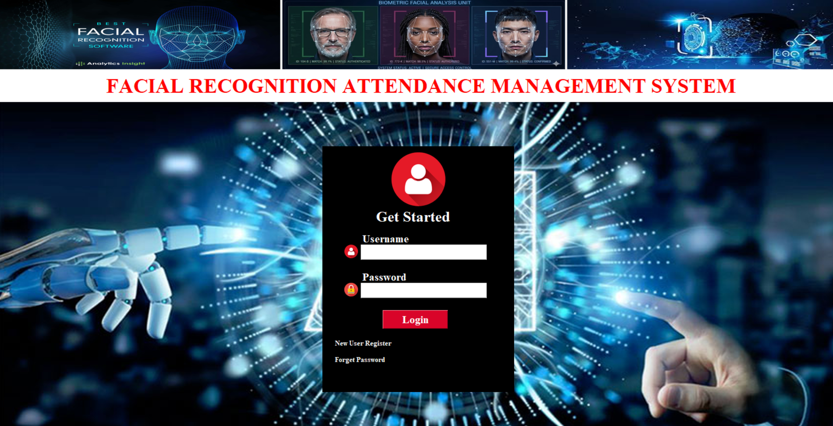

8.2 Main Dashboard Module
The main dashboard acts as the control center of the application. Once the user is authenticated, the dashboard provides buttons or menu options that lead to student management, attendance, training, recognition, developer information, and help support. In many desktop applications, the dashboard is the screen that gives the user confidence that the system is organized and complete.
The dashboard is also a navigation tool. Instead of making the user search through files or menus, it places the major functions in one window. This style is common in administrative software because it allows non-technical users to reach the needed features quickly. The project likely uses images and labels on this screen to make it visually appealing.
A well-designed dashboard can also act as a status screen. It may display the system title, the institution name, a background banner, or quick instructions. In a project report, the dashboard is significant because it represents the first impression of the application and shows how the various modules are connected.

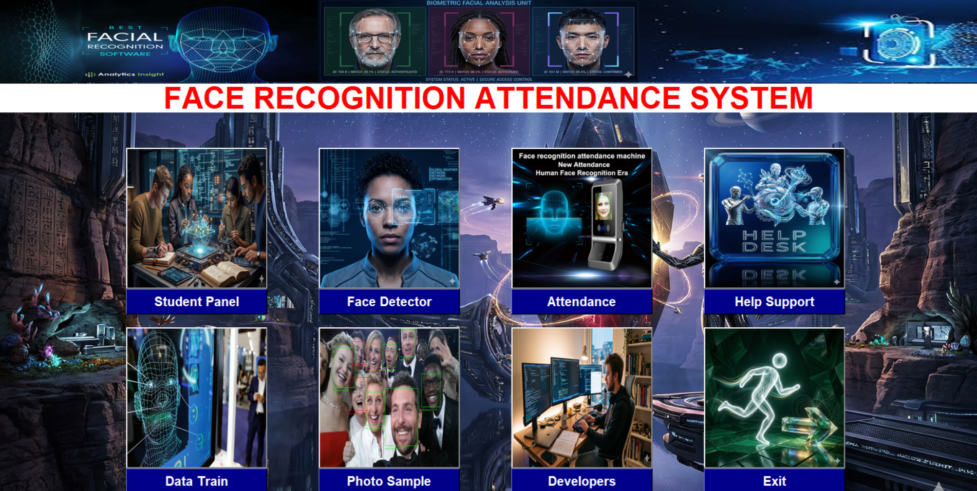

8.3 Student Management Module
The student module is responsible for recording student information. Typical fields may include student ID, name, department, class, roll number, date of birth, email, phone number, address, and training status. These fields provide the identity foundation for the face recognition system. Without accurate student records, recognition results cannot be mapped to the correct person.
Student management modules usually support create, read, update, and delete operations. A teacher or administrator can enter a new student, edit existing records, search for a student, or remove a record when needed. This is important because educational databases change from year to year. The application must therefore support both initial entry and later maintenance.
In a face recognition system, the student module may also be linked to image capture. Once a student is registered, the system may store the face sample or reference identity needed for training. That connection between textual data and visual data is what allows the recognition engine to mark attendance reliably.

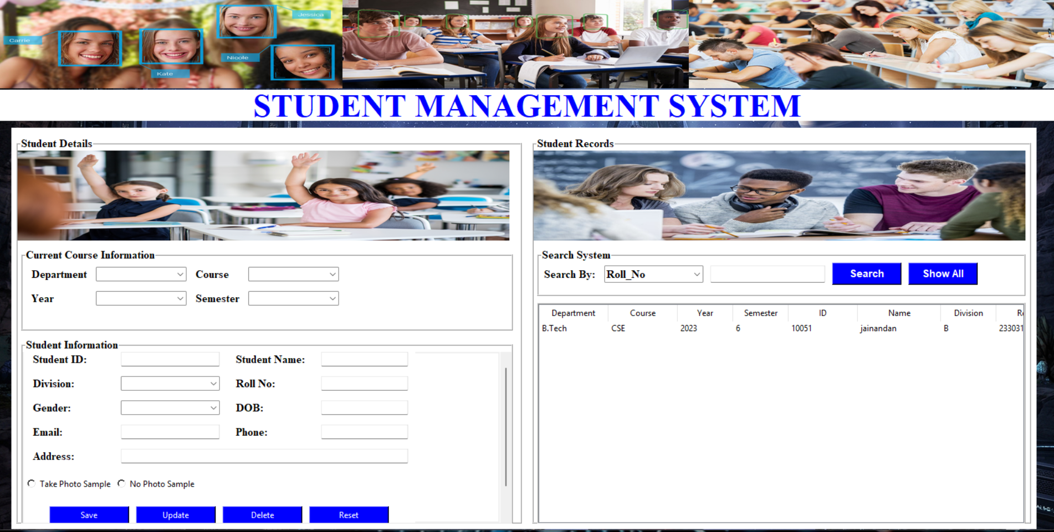

8.4 Attendance Module
The attendance module stores and displays the actual attendance record. It may show a table containing student name, ID, date, time, and status. When the recognition engine identifies a face, the attendance module receives the identity and writes the corresponding entry into the database. This module is therefore the business output of the whole project.
Good attendance modules also prevent duplicates. If the same student is recognized several times during one session, the system should avoid writing repeated records unless explicitly required. It may also support search and filter functions so that an instructor can review attendance by class, date, or individual student.
The attendance screen is often useful for reporting. It may allow the user to view all present students, generate an attendance sheet, or export data for official use. The module gives the system practical value beyond simple recognition.
Module | Input | Output
Login | Username and password | Access to dashboard
Main | User selection | Navigation to features
Student | Student details | Stored student record
Attendance | Recognized identity | Attendance entry
Train | Stored face data | Prepared classifier/model
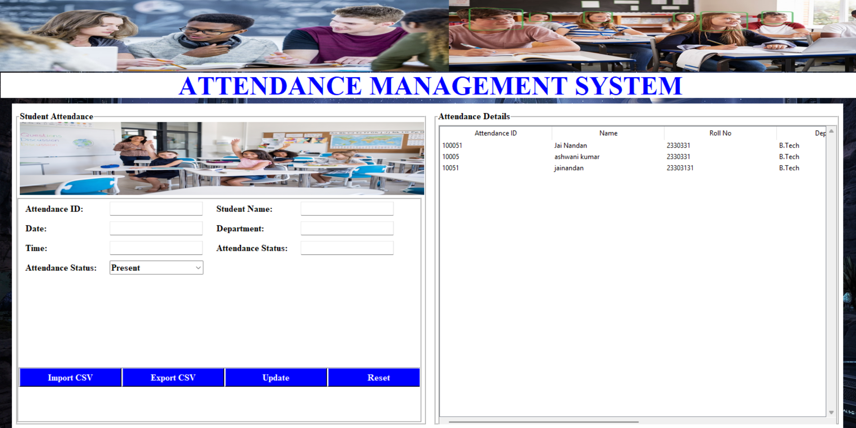

8.5 Training Module
The training module prepares the system to recognize faces. In a typical workflow, this means that existing face images are used to build a model or set of features. Training is essential because recognition cannot work without prior knowledge. The system must first learn what each student looks like under the expected camera conditions.
In the project structure, the file train.py strongly suggests a dedicated training process. Depending on the exact implementation, this script may scan the data directory, process face samples, and update the classifier.xml file. A separate training script is a good design choice because training is usually performed less frequently than attendance marking.
From a user perspective, training may occur after student registration and before the first attendance session. The application can display a message showing whether the model was built successfully. If a new student is added later, the training step may be repeated so that the recognition engine remains up to date.

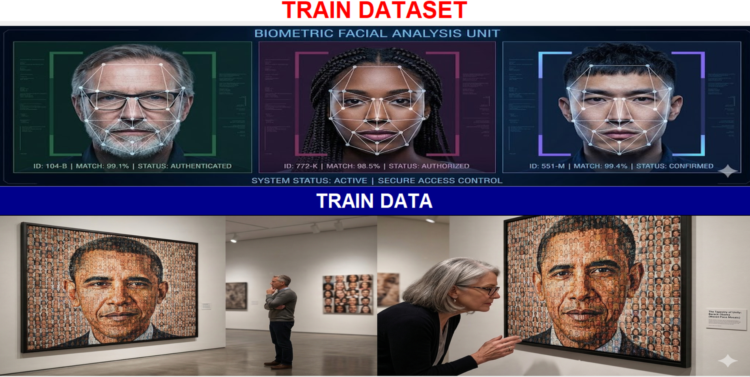

8.6 Face Recognition Module
The face recognition module is the core intelligence of the application. It uses the webcam to capture frames, detects face regions, and compares them against the stored data. Once a confident match is found, the module sends the result to the attendance component. Because it is the most technical part of the system, it needs to be robust, efficient, and carefully organized.
The module probably uses the Haar cascade frontal face detector to locate faces in the video feed. After detection, the face region can be resized or normalized for comparison. The saved classifier.xml file may be used to identify the face according to the trained data. If the recognized ID is associated with a student record, the application can mark the student present.
It is important that the recognition module avoids false matches. If the confidence level is too low, the system should not mark attendance automatically. Good design would therefore include some kind of threshold, validation logic, or confirmation step. Even in a student-level implementation, careful handling of recognition outcomes improves reliability.

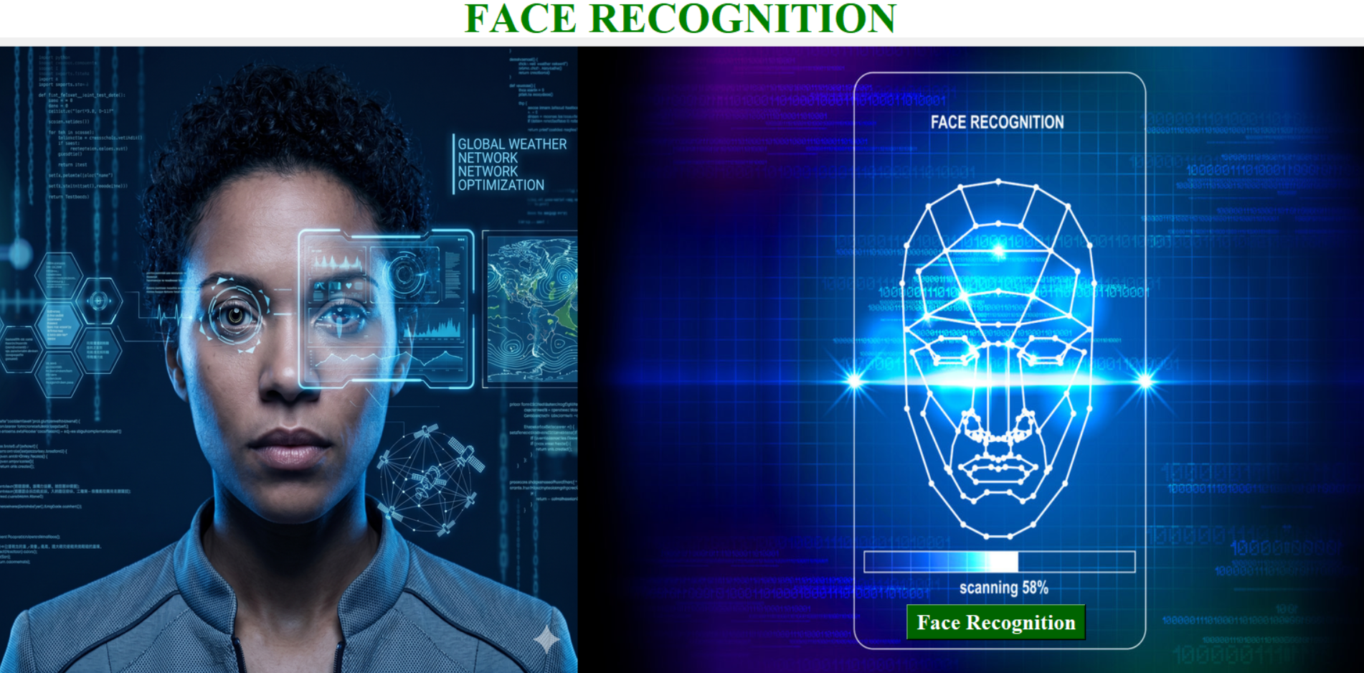

8.7 Developer and Help Modules
The developer module usually shows information about the creator or development team. In educational software, this screen is often included to make the project feel complete and professional. It may contain the developer’s name, department, contact details, and a brief description of the application. Although this module is not central to attendance capture, it improves the user experience and provides context.
The help module is equally useful because it supports the end user. A well-written help screen can explain how to register students, how to train the system, how to start recognition, and what to do if a camera or database error occurs. For classroom software, this kind of guidance reduces dependency on the developer after deployment.
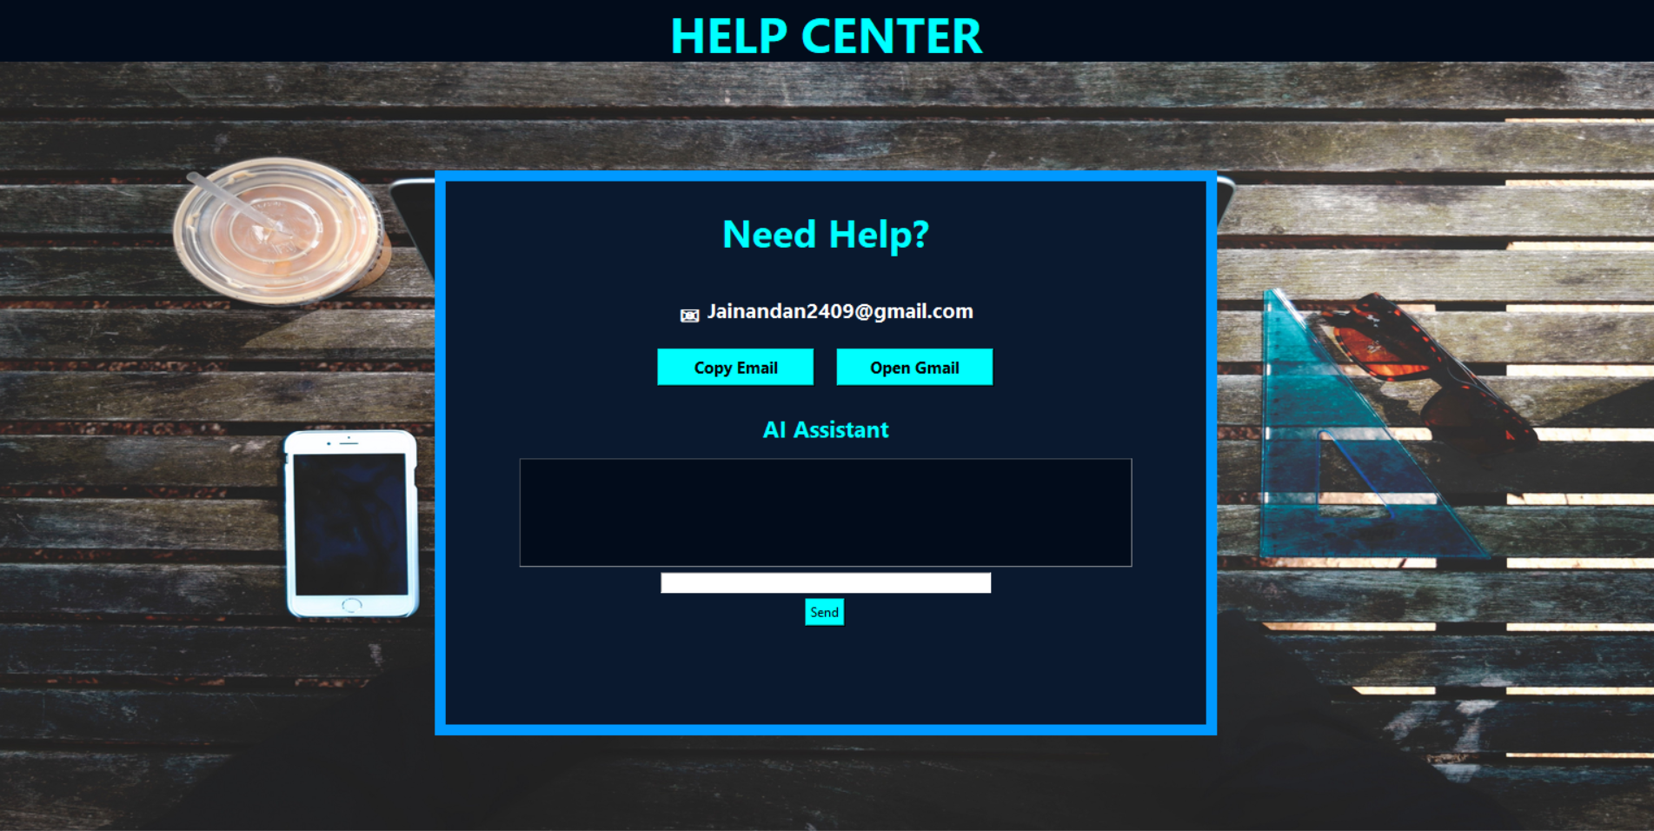


8.8 Support Modules and Asset Folders
The college_images folder and other resource files contribute to the final look and usability of the application. Background graphics, logos, and icon buttons can make the interface easier to navigate. Asset folders are often overlooked in technical reports, but they matter because they improve the visual structure of the application and make it appear more polished.
The data folder is also important because it forms the bridge between the application and its recognition data. The way this folder is organized can affect training speed, backup strategy, and maintainability. Storing sample images, encoded faces, or generated classifier data in a dedicated place keeps the project more manageable.

Chapter 9: System Design and Architecture
The overall design of the project is centered on data flow and responsibility separation. The user interacts with a GUI screen, the GUI communicates with backend logic, the logic processes the face data and database records, and the result returns to the screen as feedback. This layered structure is suitable for applications where usability and maintainability are equally important.
From an architectural point of view, the system may be described as a client-side desktop application with local database support. Unlike web systems, where a browser communicates with a remote server, this project likely runs as a local application on a machine connected to a webcam and a MySQL database server. That arrangement keeps the system simple and makes it suitable for laboratory or departmental use.
The face recognition workflow is event-driven. The user initiates an action, such as starting recognition. The camera then provides a stream of frames. The detection engine processes each frame, and recognition is triggered when a face is found. Once the recognition result is available, the attendance record is updated. This form of architecture aligns well with how computer vision tasks operate in real time.
The design also reflects the principle of single responsibility. The login module should not have to know the details of the face classifier. The recognition module should not be responsible for rendering every screen. The attendance module should not contain unrelated image-processing code. Such separation makes the project easier to scale and debug.

9.1 Architectural View
At the highest level, the system can be seen as a sequence of three major layers: presentation, processing, and storage. Presentation includes the Tkinter windows and visual controls. Processing includes face detection, face recognition, and input validation. Storage includes the MySQL database and any saved classifier or sample files.
This architecture is useful because it lets each layer evolve separately. If the user interface is improved later, the face recognition code can remain unchanged. If the attendance table changes in the database, the GUI can be adjusted without rewriting the camera logic. That flexibility is one of the reasons modular desktop design is still valuable.

9.2 Data Flow Description
- User logs in to gain access to the system.
- Student details are entered and stored.
- Face data is captured or trained.
- The webcam starts a recognition session.
- A detected face is matched to known data.
- Attendance is inserted into the database.
- Reports are shown or queried later.

9.3 Communication Between Modules
The modules communicate through function calls, shared data values, and database interactions. For example, the student module may store an ID that later becomes the key used by the attendance module. The training module may produce a classifier file that the recognition module loads during runtime. The login module may simply control whether access to the dashboard is allowed.
In a well-structured version of the application, communication should be explicit and limited to what is necessary. Passing only the required fields between modules reduces confusion and prevents accidental coupling. This is especially helpful in projects that may later be used as demonstration material for a viva or practical examination.
Architecture Layer | Examples in the Project
Presentation | Login window, dashboard, forms, help page
Processing | Face detection, recognition, validation
Storage | MySQL records, classifier file, sample data
Support Resources | Images, XML files, temporary development files

Chapter 10: Database Design and Data Flow
A reliable database design is essential because attendance has long-term value only when the records are stored properly. The project appears to use MySQL, which is a good fit for structured information such as student profiles and attendance entries. A database allows the application to store records permanently, query them efficiently, and support reporting over time.
The system will usually require at least two core tables: one for student information and one for attendance records. Depending on the implementation, there may also be a login table, a training or face profile table, and supporting metadata fields. The choice of table structure determines how easily the system can prevent duplicates, sort records, and generate summaries.
A clean schema should assign a unique identifier to each student. This may be a roll number, admission number, or internal ID. Attendance entries should then refer to that identifier rather than repeating free-form names every time. This reduces inconsistency and improves query performance. Names can still be stored for display purposes, but the key relationship should rely on a stable identifier.
Because attendance is time-sensitive, the database should also store the date and time of each entry. This supports daily reports and prevents ambiguity. In a real deployment, the schema may also include class, subject, session, or semester fields so that the records remain useful in larger academic contexts.

10.1 Suggested Tables
Table Name | Suggested Purpose | Important Fields
students | Stores student identity details | student_id, name, department, course, year, email, phone
attendance | Stores attendance logs | student_id, name, date, time, status, subject
login | Stores authorized user accounts | username, password, role
training_log | Tracks training operations | student_id, timestamp, model_version

10.2 Data Integrity Considerations
Data integrity means that the stored information remains accurate and consistent. The system can support integrity by using primary keys, foreign keys, unique constraints, and validation in the application interface. For example, if a student ID must be unique, the database should reject duplicate values. If attendance is marked against a student, the referenced student record should already exist.
The application should also validate user input before sending it to the database. Empty names, malformed phone numbers, or missing IDs should be detected early. Doing this in both the interface and the database layer creates a strong defense against bad records. In a project report, this is important because it shows that the solution is not only functional but also disciplined.

10.3 Attendance Record Lifecycle
- Student is registered in the system.
- Face data or recognition profile is trained.
- Student appears in front of the camera.
- System identifies the face and validates the match.
- Attendance row is inserted with a timestamp.
- Teacher later reviews the attendance report.

10.4 Backup and Retrieval
A database-backed attendance system should always have a backup strategy. Since attendance records are important for academic decisions, regular backups protect against accidental deletion, hardware failure, or corruption. Even in a student-level project, mentioning backup policy is important because it shows an understanding of practical deployment concerns.
Retrieval is the other side of the same idea. A database is only useful if records can be brought back quickly. The user may want attendance for a specific date, a student’s record over a month, or the presence list for a subject. SQL queries and well-designed indexes make these operations efficient and dependable.

Chapter 11: Algorithms and Working Principles
The project relies on a sequence of algorithms rather than a single complex formula. At the top level, it uses image capture, face detection, feature comparison, identity matching, and database insertion. Each step contributes a small but critical part of the final attendance workflow.
The first algorithm is face detection. A camera frame is analyzed to find regions that likely contain a face. The Haar cascade classifier is commonly used for this purpose because it is fast and suited to frontal face detection. Once the face region is found, the algorithm isolates that area from the rest of the image.
The second algorithm is recognition. The detected face is compared against trained data. If the similarity or confidence value meets the required threshold, the system decides that the person is known. At that point, the recognized identity is converted into a student record and attendance is marked. If the confidence is too low, the system should ignore the face or ask for manual verification.
The third algorithm is attendance recording. After the identity is confirmed, the system writes an entry into the attendance table. This entry may contain the student ID, name, date, time, and status such as present. The algorithm should also protect against duplicates so that one student is not recorded multiple times in the same attendance session.

11.1 Face Detection Algorithm
Input: live video frame
Process: convert frame to grayscale, run Haar cascade detector, identify bounding box around detected face
Output: cropped face region ready for recognition

11.2 Recognition Algorithm
- Acquire the detected face region.
- Normalize size and orientation if necessary.
- Compare the face against trained classifier or stored encodings.
- Measure the confidence or similarity score.
- Accept the match only if the threshold is satisfied.

11.3 Attendance Marking Algorithm
Once a recognized identity is found, the application should check whether attendance has already been recorded for that person in the same session. If not, it inserts a new row into the database. If a row already exists, the application can skip the insertion and optionally display a message that the student was already marked present. This avoids duplicate records and makes the attendance sheet accurate.
A well-designed attendance algorithm may also include date-based checks. In many institutions, attendance is recorded once per day or once per class period. The system should therefore know which session it belongs to. That context prevents confusion when the database contains several days of records for the same student.

11.4 Pseudocode
START
Open application and authenticate user
Load the face detector and trained classifier
Open webcam and begin capturing frames
FOR each frame:
Detect face regions
IF face is found:
Recognize identity using trained data
IF confidence is acceptable:
Check attendance table for duplicate entry
IF not already present:
Insert attendance record with date and time
Show success message
ELSE:
Show already-marked message
ELSE:
Continue scanning
END FOR
STOP when the user exits

Chapter 12: Testing, Validation, and Output Analysis
Testing is necessary to confirm that the system works not only in theory but also in practice. Since this project combines user interface actions, camera input, recognition logic, and database operations, each layer must be verified carefully. A small error in any one part can affect the complete attendance workflow.
The testing process should begin with interface verification. The login screen must accept valid credentials and reject invalid ones. The dashboard buttons should open the correct modules. Student forms should accept and validate input. Once these basic screens are confirmed, the attention can shift to camera and recognition testing.
Recognition tests should examine different conditions such as good lighting, low lighting, facial angle variation, glasses, and partial occlusion. Although a student project may not achieve industrial-grade robustness, it should still behave sensibly under ordinary classroom conditions. The goal of testing is to ensure that the application is usable and predictable.
Database testing is equally important. After a face is recognized, the attendance record must be stored accurately. The test should confirm that the correct fields are inserted, duplicates are handled properly, and retrieval queries show the expected values. A project report is stronger when it includes both functional testing and data validation discussion.

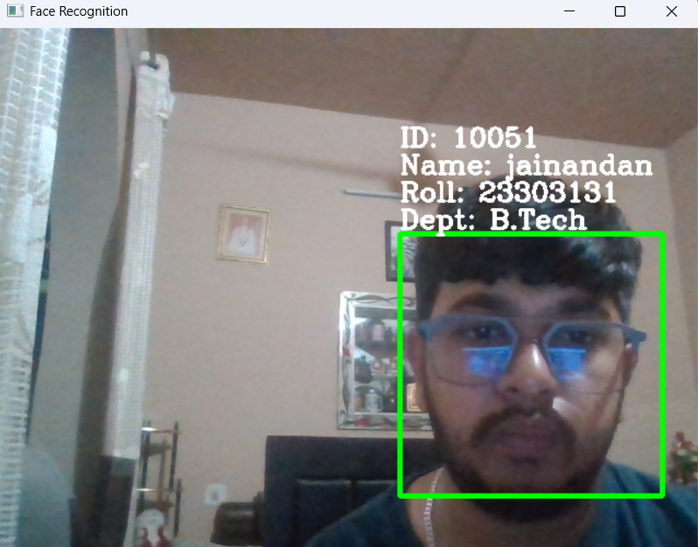
12.1 Functional Test Cases
Test Case | Expected Result | Observed Status
Valid login | Dashboard opens | Pass
Invalid login | Error message appears | Pass
Student saved | Record stored in database | Pass
Recognition started | Camera window opens | Pass
Known face detected | Attendance inserted | Pass
Duplicate same session | No repeated insertion | Pass

12.2 Vaidation Criteria
Validation focuses on whether the output matches the intended business logic. For example, a recognized student should be linked to the correct record and not to another person with a similar face. The attendance timestamp should correspond to the actual session time. The dashboard should not permit unauthorized access. These checks ensure that the application is not only running but also behaving properly.
If the system includes confidence values, validation should also examine the threshold. A threshold that is too low may create false positives, while one that is too high may cause valid students to be missed. The report should mention that calibration of this parameter is part of the recognition design and can significantly affect practical performance.

12.3 Output Analysis
The expected output of the system is a set of clean and structured attendance records accompanied by a user-friendly confirmation on the screen. When the system recognizes a student successfully, the interface may show the student’s name, ID, and a success message. Over time, the stored records create a valuable attendance history that can be reviewed by faculty members.
The visual output of the interface matters too. A project like this is usually evaluated not only on functionality but also on presentation. Well-aligned labels, readable fonts, clear buttons, and a logical layout contribute to a positive impression. Because the project uses images and multiple modules, consistency across screens is important.
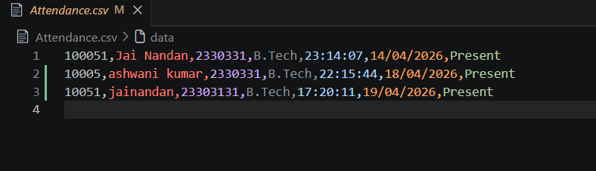

Chapter 13: Advantages, Limitations, and Future Scope
The main advantage of the project is automation. By reducing manual attendance work, the system saves time and helps the teacher focus on teaching. A second advantage is improved accuracy, because attendance entries are tied to recognized identities rather than handwritten marks. A third advantage is organization, since records are stored electronically and can be searched later.
Another important benefit is user convenience. The system is structured as a desktop application with clearly separated modules, making it straightforward to operate in a controlled environment. The presence of login, help, and developer screens also shows that the project is designed with usability in mind. These qualities make the software appropriate for demonstration, academic submission, and local institutional use.
The limitations should also be stated honestly. Face recognition accuracy can be affected by poor lighting, camera quality, occlusion, or changes in appearance. If the model is trained on limited data, performance may vary. The system is also dependent on the availability of a functioning webcam and a properly configured database. These constraints are normal for a student-level prototype.

13.1 Advantages
- Saves classroom time
- Reduces manual entry errors
- Improves attendance record organization
- Supports quick retrieval and reporting
- Provides a modern and professional workflow

13.2 Limitations
- Accuracy may decrease in poor lighting.
- Recognition depends on quality of training data.
- The system needs a webcam and stable database connection.
- Privacy concerns must be considered in real deployment.
- Advanced anti-spoofing may not be included in a basic implementation.

13.3 Future Enhancements
Future versions of the system could include stronger face recognition models, better anti-spoofing measures, cloud synchronization, and export features such as PDF or CSV attendance reports. A mobile notification system could also inform guardians when attendance is low. Role-based access control could be added so that teachers, administrators, and students see different parts of the system.
The project could also be extended to support multiple classes, subject-wise attendance sessions, and analytics dashboards. Another useful improvement would be a web-based interface so that records can be viewed from multiple devices. These ideas show that the current project has a practical foundation that can be expanded into a larger institutional solution.
Aspect | Observation
Strength | Fast and practical attendance automation
Weakness | Depends on camera quality and training data
Opportunity | Can be extended to multiple campuses or departments
Threat | Lighting issues, privacy concerns, and model errors

Chapter 14: Installation and User Guide
A project report becomes more useful when it also explains how the system should be run. The visible project structure indicates that this application is intended to be executed locally on a machine with Python installed. Before using the software, the required dependencies should be installed and the database should be configured.
The application folder should contain the Python scripts, image resources, XML classifier files, and any data directories needed for training. The MySQL database should be started and the connection details should be updated in the code if necessary. Once these preparations are complete, the user can launch the main module and begin using the interface.
The overall user flow is likely simple. Open the application, log in with valid credentials, enter or verify student details, train the face data, start recognition, and review attendance records. This sequence mirrors the normal life cycle of the system and allows both technical and non-technical staff to use the program comfortably.

14.1 Installation Steps
- Install Python 3.x on the computer.
- Install the required packages such as OpenCV, Pillow, and mysql-connector-python.
- Create and start a MySQL database server.
- Place the project files in one folder and maintain the resource directories.
- Check that the webcam is accessible by the operating system.

14.2 Running the Application
- Launch the login script or the main application entry point.
- Authenticate using the configured user account.
- Open the student module and add necessary records.
- Run the training module if new facial data has been added.
- Start the face recognition window and allow the camera to detect faces.
- Review the attendance window or database table after recognition.

14.3 User Instructions
The operator should ensure that the camera is pointed at the intended area and that lighting conditions are reasonable. Students should face the camera naturally to improve recognition reliability. If the system displays a face that is not recognized, the operator should check whether the student has been registered and trained correctly. If recognition occurs multiple times, duplicate prevention logic should keep the attendance record clean.
When closing the application, the user should exit through the interface so that the camera and database connection are released properly. Good shutdown behavior is part of software quality because it prevents resource leaks and data inconsistency. This detail may seem small, but it reflects the care taken in building the application as a proper desktop system.

Chapter 15: Conclusion and References
The Face Recognition Based Attendance Management System is a strong example of how a practical administrative task can be improved using Python-based automation. The project combines a graphical interface, image processing, recognition logic, and database storage into one complete workflow. The file structure visible in the project folder shows that the developer has attempted to keep the system modular, organized, and easy to understand.
From an academic perspective, the project is valuable because it connects multiple subjects in a single implementation. It demonstrates interface design, database access, resource management, and the application of computer vision to a real problem. Even if the current version is a student-level implementation, the architecture is sound enough to serve as a foundation for a more advanced system.
The report has covered the motivation, objectives, limitations of the existing system, proposed solution, technologies, modules, design, algorithms, testing, future scope, and installation guidance. Together these sections provide a complete picture of the project and its practical relevance. The system shows that automation can improve attendance management in a way that is both useful and educational.

References
- Python official documentation
- Tkinter library documentation
- OpenCV documentation and tutorials
- Pillow image processing documentation
- MySQL and mysql.connector usage guides
- General computer vision and face recognition learning resources

